.

**DeptofArtificialIntelligenceandMachineLearning**|**RajalakshmiEngineeringCollege**

153

09–Dictionary

**vEx.No. : 9.1 Date:**4/5/24

.

**DeptofArtificialIntelligenceandMachineLearning**|**RajalakshmiEngineeringCollege**

154

**RegisterNo.:231501042 Name: Dinesh Karthik K**

# Uncommonwords

Asentenceisastringofsingle-spaceseparatedwordswhereeachwordconsistsonly of lowercase letters.A word is uncommon if it appears exactly once in one of the sentences, and does not appear in the other sentence.

Given two sentences s1 and s2, return a list of all the uncommon words. You mayreturn the answer in any order.

**PROGRAM**

s1=input() s2=input()

words1=s1.split() words2= s2.split()

count={}

forwordinwords1+words2: if word in count:

count[word]+=1 else:

count[word]=1

uncommon_words = [word for word in count ifcount[word] == 1] print(uncommon_words)

**Output:**

.

**DeptofArtificialIntelligenceandMachineLearning**|**RajalakshmiEngineeringCollege**

155

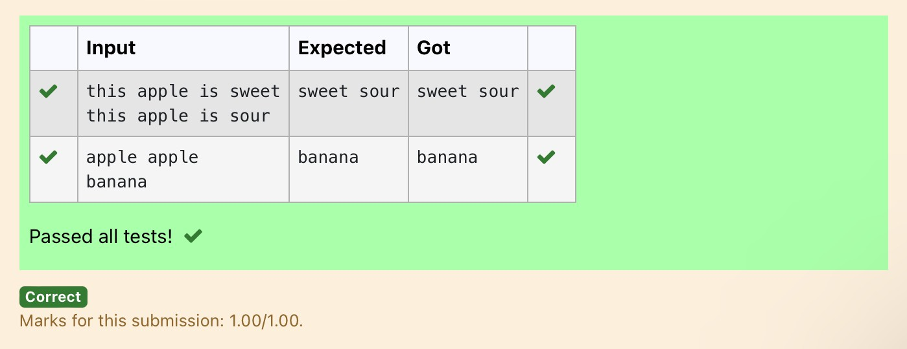

**Ex.No. : 9.2 Date:**4/5/24

.

**DeptofArtificialIntelligenceandMachineLearning**|**RajalakshmiEngineeringCollege**

156

**RegisterNo.:231501042 Name: Dinesh Karthik K**

# Sort DictionarybyValuesSummation

Giveadictionarywithvaluelists,sortthekeysbysummationofvaluesinvaluelist.

**Input**:test_dict={‘Gfg’:[6,7,4],‘best’:[7,6,5]}

**Output**:{‘Gfg’:17,‘best’:18}

**Explanation** : Sorted by sum, and replaced. **Input** : test_dict = {‘Gfg’ : [8,8], ‘best’ : [5,5]} **Output** : {‘best’: 10, ‘Gfg’: 16}

**Explanation**:Sortedbysum,andreplaced.

SampleInput: 2

Gfg674

Best 7 6 5 SampleOutput Gfg 17

Best18

## Forexample:

|  |  |
| --- | --- |
| **Input** | **Result** |
| 2  Gfg674  Best765 | Gfg17  Best18 |

**PROGRAM**

.

**DeptofArtificialIntelligenceandMachineLearning**|**RajalakshmiEngineeringCollege**

157

n=int(input()) l1=[]

l2=[]

l3=[]

d=dict()

for i in range(n): l1=input().split("")

l2.append(l1[0]) l1.pop(0) l3.append(l1)

forjinrange(len(l3)): sum=0

for k in l3[j]: sum+=int(k)

l3[j]=sum

foriinrange(len(l2)): d[l2[i]]=l3[i]

dn=dict(sorted(d.items(),key=lambdaitems:items[1])) for key,value in dn.items():

print(f"{key}{value}")

## Output:

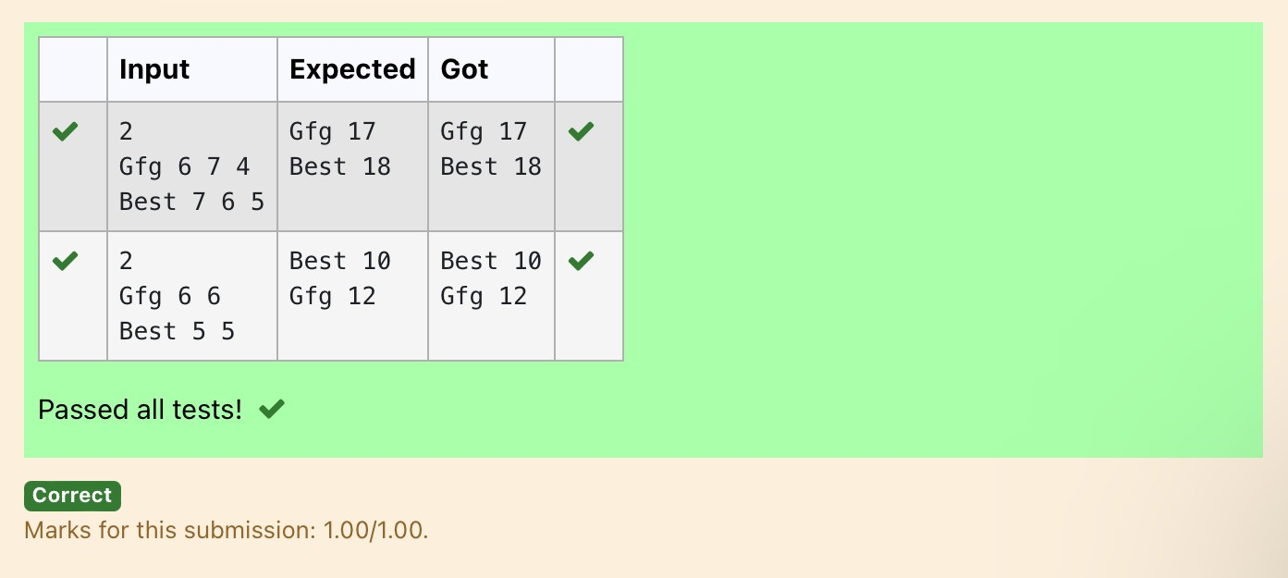

**Ex.No. : 9.3 Date:**4/5/24

.

**DeptofArtificialIntelligenceandMachineLearning**|**RajalakshmiEngineeringCollege**

158

**RegisterNo.:231501042 Name: Dinesh Karthik K**

# WinnerofElection

Given an array of names of candidates in an election. A candidate name in the array represents a vote cast to the candidate. Print the name of candidates received Max vote. If there is tie, print a lexicographically smaller name.

## Examples:

Input:votes[]={"john","johnny","jackie", "johnny", "john", "jackie",

"jamie","jamie","john",

"johnny", "jamie", "johnny", "john"};

Output:John

We have four Candidates with name as 'John','Johnny','jamie','jackie'. The candidates John and Johny get maximum votes. Since John is alphabetically smaller, we print it. Use dictionary to solve the above problem

## SampleInput:

10

John John Johny Jamie Jamie Johny Jack Johny Johny Jackie

## SampleOutput:

Johny

## Forexample:

.

**DeptofArtificialIntelligenceandMachineLearning**|**RajalakshmiEngineeringCollege**

159

|  |  |
| --- | --- |
| **Input** | **Result** |
| 10  John John Johny Jamie Jamie Johny Jack Johny Johny Jackie | Johny |

**PROGRAM**

n=int(input()) l1=[]

d=dict()

for i in range(n): l1.append(input())

for j in l1: d[j]=l1.count(j)

n1=max(d) m=d[n1] d.pop(n1) n2=max(d) if(m==d[n2]):

if(len(n1)<len(n2)): print(n1)

else:

print(n2)

else:

print(n1)

Output:

.

**DeptofArtificialIntelligenceandMachineLearning**|**RajalakshmiEngineeringCollege**

160

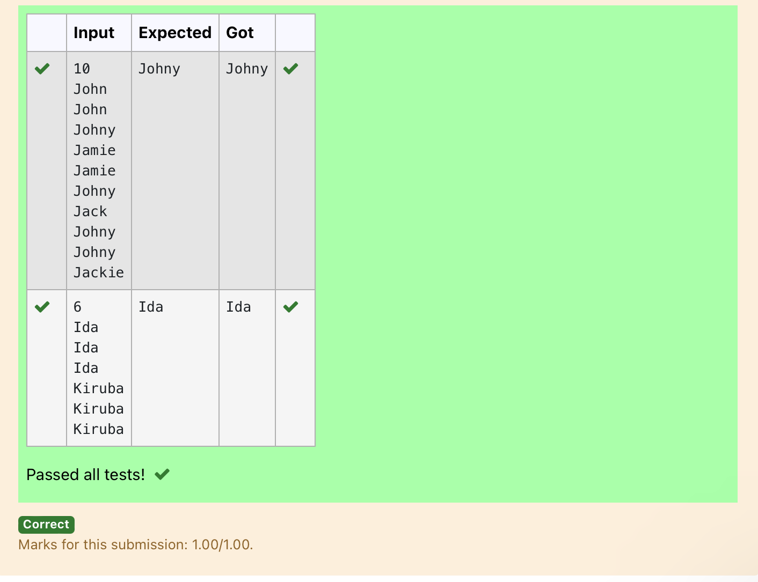

v

**Ex.No. : 9.4 Date:**4/5/24

.

**DeptofArtificialIntelligenceandMachineLearning**|**RajalakshmiEngineeringCollege**

161

**RegisterNo.:231501042 Name: Dinesh Karthik K**

# StudentRecord

Createastudentdictionaryfornstudentswiththestudentnameaskeyand their test mark assignment mark and lab mark as values. Do the following computations and display the result.

1. Identifythestudentwiththehighest[average](https://www.rajalakshmicolleges.net/moodle/mod/quiz/view.php?id=5717) score
2. IdentifythestudentwhoasthehighestAssignmentmarks
3. IdentifythestudentwiththeLowestlabmarks
4. Identify the student with the lowest [average](https://www.rajalakshmicolleges.net/moodle/mod/quiz/view.php?id=5717) score Note:

Ifmorethanonestudenthasthesamescoredisplayallthestudentnames

Sampleinput: 4

James67 8956

Lalith894545

Ram898989

Sita 70 70 70 SampleOutput: Ram

JamesRam Lalith Lalith

**PROGRAM**

**DeptofArtificialIntelligenceandMachineLearning**|**RajalakshmiEngineeringCollege**

162

n=int(input()) list1=[] list2=[] list3=[] list4=[] list5=[]

for i in range(n): student_data=input()

student_input_parts=student_data.split() name=student_input_parts[0]

marks=[int(mark) for mark in student_input_parts[1:]] average=(marks[0]+marks[1]+marks[2])/3 list1.append(name)

list2.append(marks[0]) list3.append(marks[1]) list4.append(marks[2]) list5.append(average)

l1=[]

foriinrange(n):

if list5[i]==max(list5): l1.append(list1[i])

for i in l1: print(i,end='')

print() l2=[]

foriinrange(n):

if list3[i]==max(list3): l2.append(list1[i])

for i in l2: print(i,end='')

print() l3=[]

foriinrange(n):

iflist4[i]==min(list4): l3.append(list1[i])

l3.reverse() for i in l3:

print(i,end='') print()

l4=[]

foriinrange(n):

if list5[i]==min(list5): l4.append(list1[i])

for i in l4: print(i,end='')

.

Output:

.

**DeptofArtificialIntelligenceandMachineLearning**|**RajalakshmiEngineeringCollege**

163

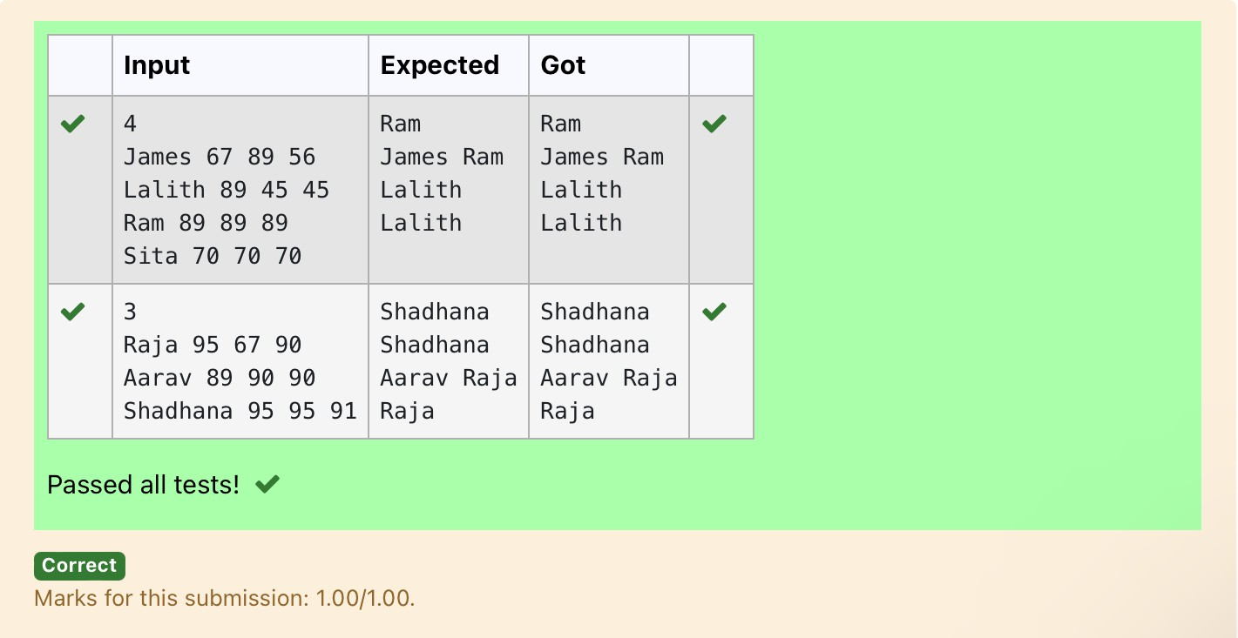

**Ex.No. : 9.5 Date:**4/5/24

**DeptofArtificialIntelligenceandMachineLearning**|**RajalakshmiEngineeringCollege**

164

**RegisterNo.:231501042 Name: Dinesh Karthik K**

# [ScrambleScore](https://www.rajalakshmicolleges.net/moodle/mod/quiz/view.php?id=5780)

InthegameofScrabble™,eachletterhaspointsassociatedwithit.Thetotalscoreof awordisthesumofthescoresofitsletters.Morecommonlettersareworth fewer points while less common letters are worth more points.

Write aprogramthatcomputesand displaysthe Scrabble™ score for aword.Create adictionarythatmapsfromletterstopointvalues.Thenusethedictionary to compute the score.

A Scrabble™ board includes some squares that multiply the value of a letter or the value of an entire word. We will ignore these squares in this exercise.

Thepointsassociatedwitheachletterareshownbelow:

Points Letters

1. A,E,I,L,N,O,R,S,TandU
2. DandG
3. B,C,MandP
4. F,H,V,WandY
5. K

8 J and X 10QandZ

[Sample](https://www.rajalakshmicolleges.net/moodle/mod/quiz/view.php?id=5127)Input REC

[Sample](https://www.rajalakshmicolleges.net/moodle/mod/quiz/view.php?id=5127)Output

RECisworth5points.

**PROGRAM**

s=input() l1=list(s)

d=dict([(1,['A','E','I','L','N','O','R','S','T','U']),(2,['D','G']),(3,['B','C','M','P']),(4,['F','H','V','W','Y']),(5,['K']),(8,['J','X']),(10,['Q','Z'])])

sum=0for j in l1:

forkey,valuesind.items(): if j in values:

sum+=key

print(f"{s}isworth{sum}points.")

.

Output:

.

**DeptofArtificialIntelligenceandMachineLearning**|**RajalakshmiEngineeringCollege**

165

